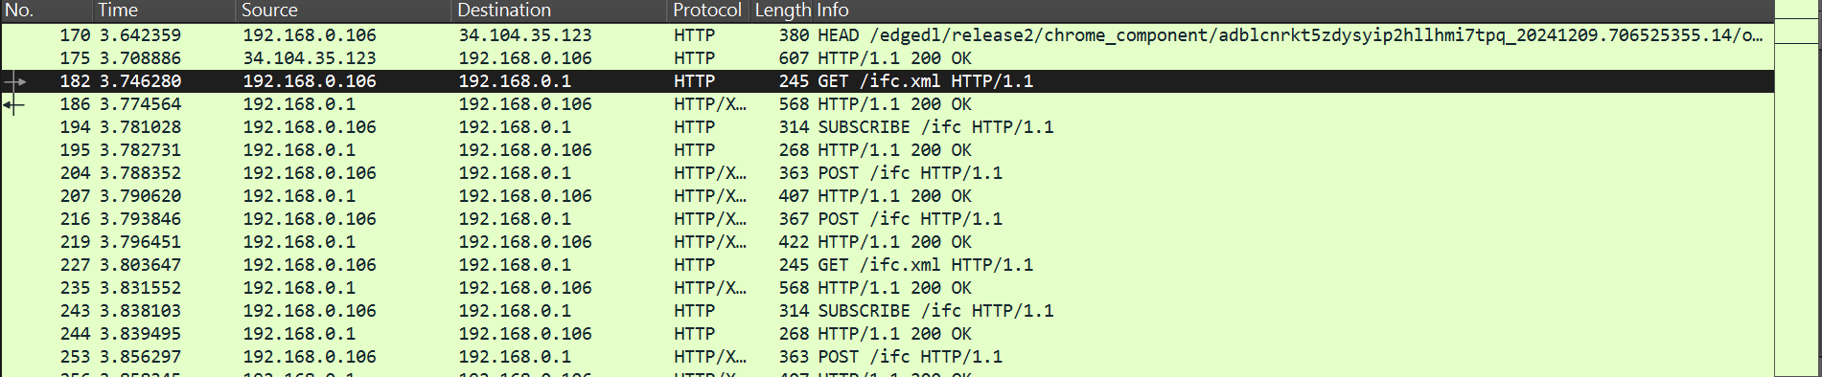

REQUEST Packet

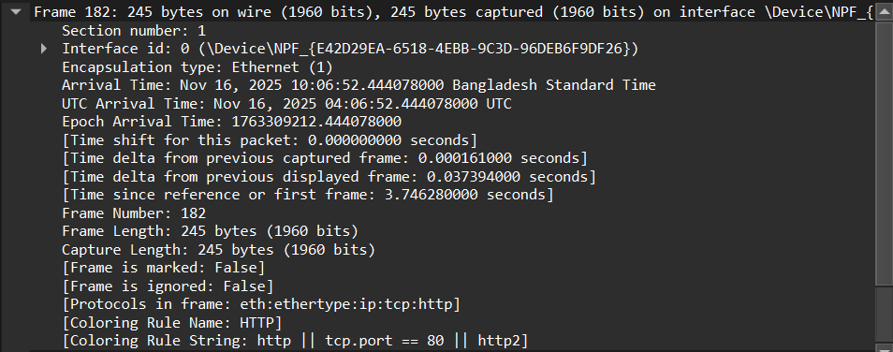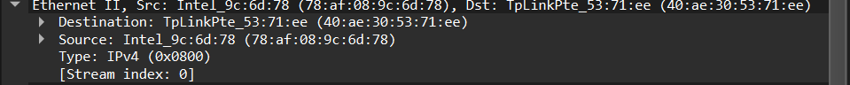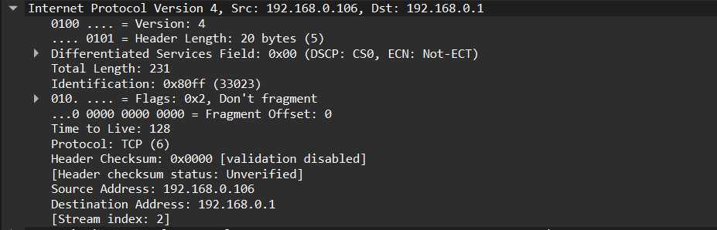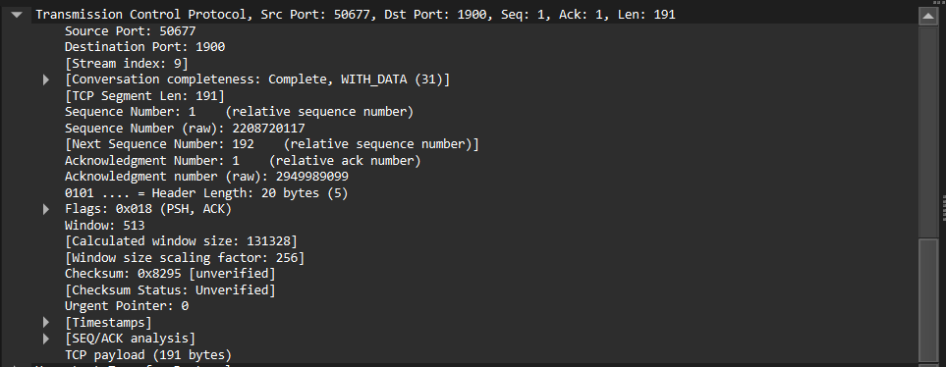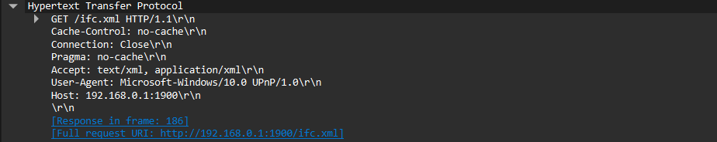

RESPONSE Packet

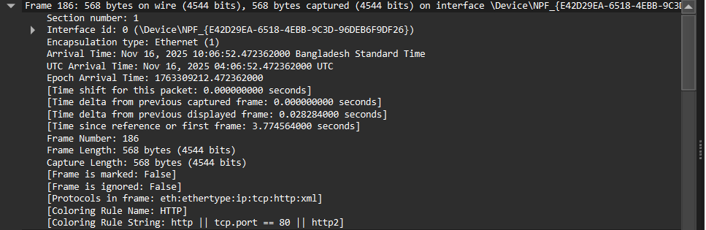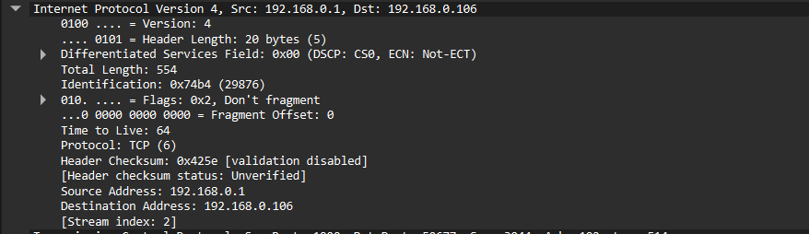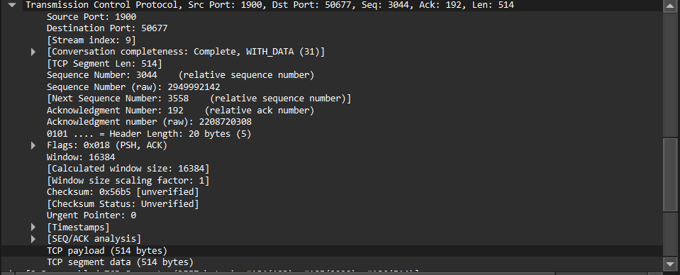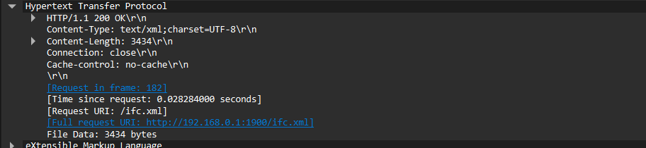

Frame - It refers to the ethernet frame, the data link layer used to transmit packets over the physical network.

Ethernet II - This protocol is used for communication at the data link layer.

Internet protocol version 4 - The network layer protocol responsible for routing and addressing packets between source and destination IP addresses.
Transmission control protocol - This is a transport layer protocol that establishes a reliable and error-checked connection between devices.

Hypertext Transfer Protocol - Application layer protocol used for requesting and delivering web resources.

